**Report**

In this session I identify the problem on my code, I read different solution in the github but any solution works for my code. So I think I will switch to arduino because it’s easier to do the same things without deeplearnig and IA. I will do that, and after when i finish i will return to the IA necause it’s very hard and that take time.

So the solution that can work it’s to choose a specific library of pandas and tensorflow, but I don’t know wich library that can works so that will take more time to try each library.

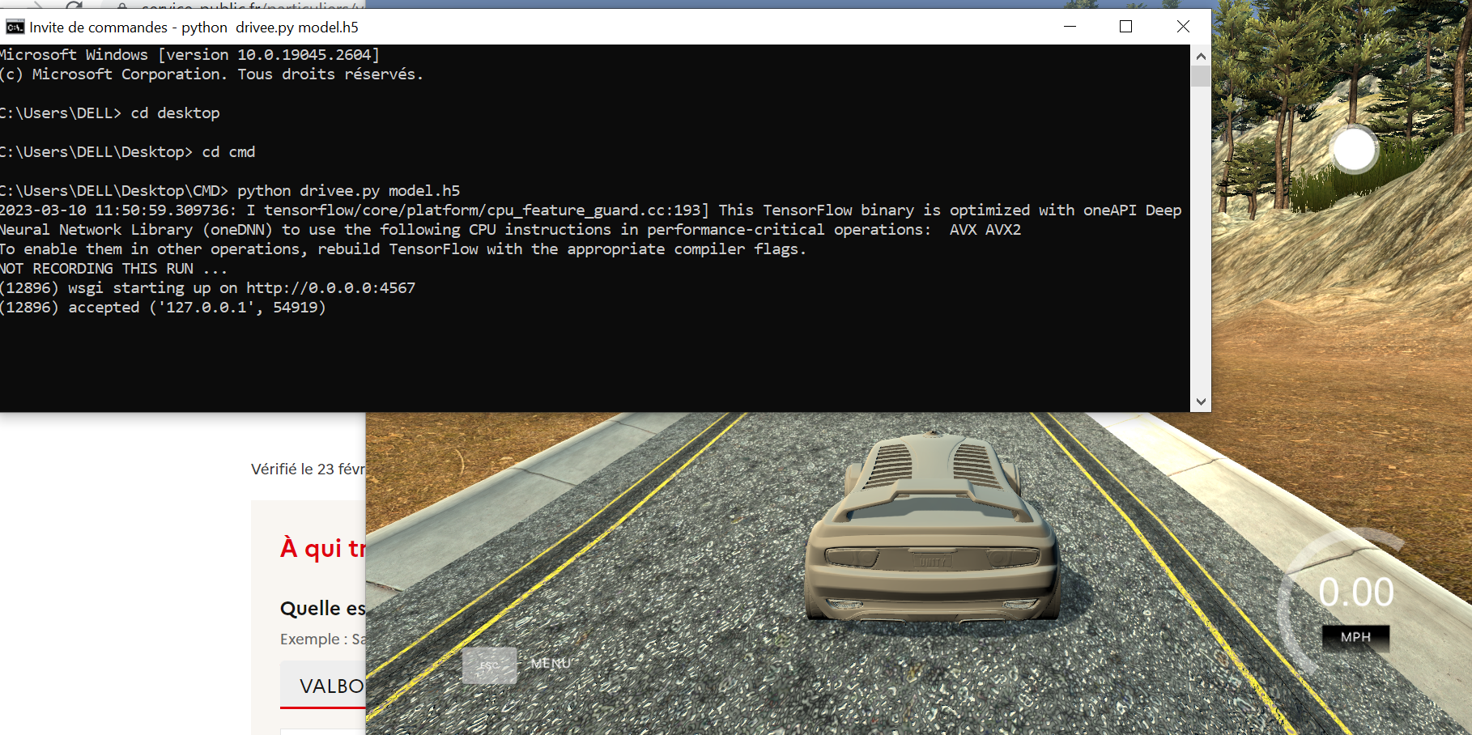

The shell was connect with the simulator but the car don’t move.